SEMINAR SYNOPSIS
ON
(AI in agriculture)



DEPARTMENT OF ELECTRONICS AND COMMUNICATIONS
MAHARAJA SURAJMAL INSTITIUTE OF TECHNOLOGY
(AFFILIATED TO GURU GOBIND SINGH INDARPRASTHA UNIVERSITY,
NEW DELHI -110058)
2017-2021

Submitted to:
Ms. Deepshikha Yadav
ECE Department

Submitted By:
(S.No. 57 – Mayank Choudhary)
(Enrolment Number - 35515002818)

Introduction

AI is making a huge impact in all domains of the industry. Every industry looking to automate certain jobs through the use of intelligent machinery. And a good Artificial Intelligence Course Online is all you need to break into any industry. Even Agriculture!
Agriculture and farming are one of the oldest and most important professions in the world. It plays an important role in the economic sector. Worldwide, agriculture is a $5 trillion industry.
The global population is expected to reach more than nine billion by 2050 which will require an increase in agricultural production by 70% to fulfill the demand. As the world population is increasing due to which land water and resources becoming insufficient to continue the demand-supply chain. So, we need a smarter approach and become more efficient about how we farm and can be most productive
In this article, I will cover are challenges faced by farmers by using traditional methods of farming and how Artificial Intelligence is making a revolution in agriculture by replacing traditional methods by using more efficient methods and helping the world to become a better place.

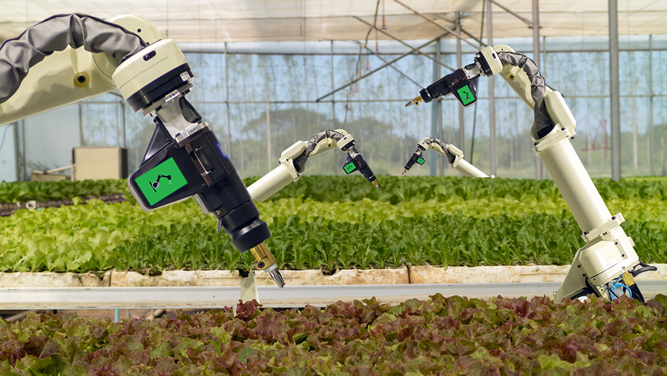

Scope of technology

Artificial intelligence is based on the principle that human intelligence can be defined in a way that a machine can easily mimic it and execute tasks, from the simplest to those that are even more complex. The goals of artificial intelligence include learning, reasoning, and perception.

The technologies which are AI-based help to improve efficiency in all the fields and also manage the challenges faced by various industries including the various fields in the agricultural sector like the crop yield, irrigation, soil content sensing, crop- monitoring, weeding, crop establishment. Agricultural robots are built in order to deliver high valued application of AI in the mentioned sector. With the global population soaring, the agricultural sector is facing a crisis, but AI has the potential to deliver much-needed solution. AI- based technological solutions has enabled the farmers to produce more output with less input and even improved the quality of output, also ensuring faster go-to- market for the yielded crops. By 2020, farmers will be using 75 million connected devices. By 2050, the average farm is expected to generate an average of 4.1 million data pointsevery day.

Thus, new automated methods were introduced. These new methods satisfied the food requirements and also provided employment opportunities to billions of people. Artificial Intelligence in agriculture has brought an agriculture revolution. This technology has protected the crop yield from various factors like the climate changes, population growth, employment issues and the food security problems. This main concern of this paper is to audit the various applications of Artificial intelligence in agriculture such as for irrigation, weeding, spraying with the help of sensors and other means embedded in robots and drones.

Applications of Artificial Intelligence in Agriculture
The industry is turning to Artificial Intelligence technologies to help yield healthier crops, control pests, monitor soil, and growing conditions, organize data for farmers, help with the workload, and improve a wide range of agriculture-related tasks in the entire food supply chain.

Use of weather forecasting: With the change in climatic condition and increasing pollution it’s difficult for farmers to determine the right time for sowing seed, with help of Artificial Intelligence farmers can analyze weather conditions by using weather forecasting which helps they plan the type of crop can be grown and when should seeds be sown.
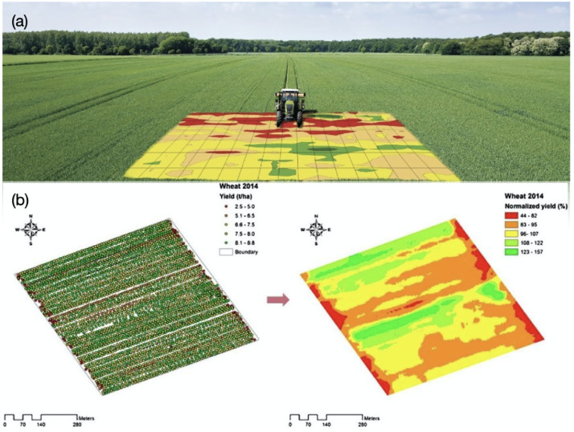
Soil and crop health monitoring system: The type of soil and nutrition of soil plays an important factor in the type of crop is grown and the quality of the crop. Due to increasing, deforestation soil quality is degrading and it’s hard to determine the quality of the soil.
AI-based application can identify the nutrient deficiencies in soil including plant pests and diseases by which farmers can also get an idea to use fertilizer which helps to improve harvest quality. This app uses image recognition-based technology.
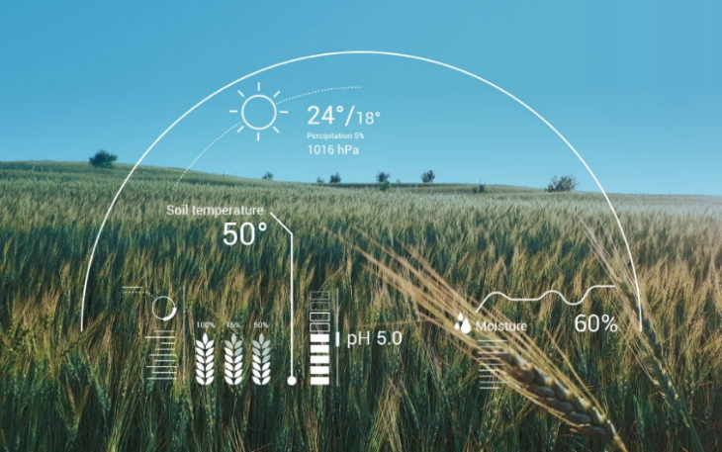
Analyzing crop health by drones: SkySqurrel Technologies has brought drone-based Ariel imaging solutions for monitoring crop health. In this technique, the drone captures data from fields and then data is transferred via a USB drive from the drone to a computer and analyzed by experts.
This company uses algorithms to analyze the captured images and provide a detailed report containing the current health of the farm. It helps the farmer to identify pests and bacteria helping farmers to timely use of pest control and other methods to take required action
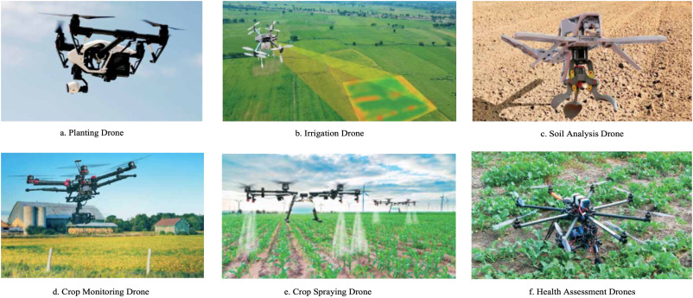

Analyzing crop health by drones: SkySqurrel Technologies has brought drone-based Ariel imaging solutions for monitoring crop health. In this technique, the drone captures data from fields and then data is transferred via a USB drive from the drone to a computer and analyzed by experts.
This company uses algorithms to analyze the captured images and provide a detailed report containing the current health of the farm. It helps the farmer to identify pests and bacteria helping farmers to timely use of pest control and other methods to take required action.

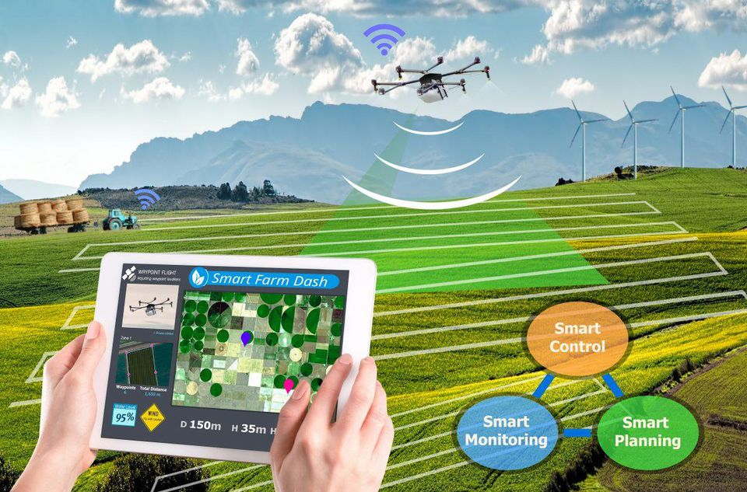

Challenges

Agriculture has been tackling significant difficulties like absence of irrigation system, change in temperature, density of groundwater, food scarcity and wastage and substantially more. The fate of cultivating depends to a great extent on reception of various cognitive solutions. While large scale research is still in progress and some applications are already available in the market, the industry is still highly underserved.

When it comes to handling realistic challenges faced by farmers and using autonomous decision making and predictive solutions to solve them, farming is still at a nascent stage. In order to explore the enormous scope of AI in agriculture, applications need to be more robust.

Only then will it be able to handle frequent changes in external conditions, facilitate real-time decision making and make use of appropriate framework/platform for collecting contextual data in an efficient manner. Another important aspect is the exorbitant cost of different cognitive solutions available in the market for farming. The solutions need to become more affordable to ensure that the technology reaches the masses. An open source platform would make the solutions more affordable, resulting in rapid adoption and higher penetration among the farmers. The technology will be useful in helping farmers in high yielding and having a better seasonal crop at regular interval. Many countries, including India, the farmers are dependent on monsoon for their cultivation. They mainly depend on the predictions from various departments over the weather conditions, especially for rain-fed cultivation. The AI technology will be useful to predict the weather and other conditions related to agriculture like land quality, groundwater, crop cycle, and pest attack, etc. The accurate projection or prediction with the help of the AI technology will reduce most of the concerns of the farmers. AI-driven sensors are very useful to extract important data related to agriculture. The data will be useful in enhancing production. In agriculture, there is a huge scope for these sensors. Agriculture scientist can derive data like quality of the soil, weather and groundwater level, etc.; these will be useful to improve the cultivation process. AI empowered sensors can also be installed in the robotic harvesting equipment in order to get the data. It is speculated that AI-based advisories would be useful to increase production by 30%. The biggest challenge to farming is the crop damage due to any kind of disasters including the pest attack. Most of the time due to lack of the proper information farmers lose their crops. In this cyber age, the technology would be useful for the farmers to protect their cultivation from any kind of attacks. AI-enabled image recognition will be useful in this direction. Many companies have implemented drones to monitor the production and to identify any kind of pest attacks. Such activities have been successful many times, which gives the inspiration to have a system to monitor and protect crops. A robotic lens zooms in on the yellow flower of a tomato seedling. Images of the plant flow into an artificial intelligence algorithm that predicts precisely how long it will take for the blossom to become a ripe tomato ready for picking, packing, and the produce section of a grocery store. The technology is being developed and researched at NatureFresh Farms, a 20-year-old company growing vegetables on 185 acres between Ontario and Ohio. Knowing exactly how many tomatoes will be available to sell in the future makes the job of the sales team easier and directly benefits the bottom line, said Keith Bradley, IT Manager for NatureFresh Farms. It's only one example of AI transforming agriculture, an emerging trend that will help spur an agricultural revolution. From detecting pests to predicting what crops will deliver the best returns, artificial intelligence can help humanity confront one of its biggest challenges: feeding an additional 2 billion people by 2050, even as climate change disrupts growing seasons, turns arable land into deserts, and floods once-fertile deltas with seawater. The United Nations estimates we will need to increase food production 50% by the middle of the century. Agricultural production tripled between 1960 and 2015 as the world's population grew from 3 billion people to 7 billion. While technology played a role in the form of pesticides, fertilizers, and machines, much of the gains can be attributed to simply plowing more land—cutting forests and diverting fresh water to fields, orchards, and rice paddies. We will have to be more resourceful this time around. AI is likely to transform agriculture and the market in the next few years. The technology has been useful for the farmers to understand various types of hybrid cultivations which would yield them more income within the limited time frame. The proper implementation of AI in agriculture will help the cultivation process and to create an ambiance for the market. As per the data with leading institutions, there is a huge wastage of the food across the world and using the right algorithms, this problem can also be addressed which will not only save the time and money but it will lead to sustainable development. There are better prospects for digital transformation in agriculture backed by leveraging technologies like AI. But, it all depends on the huge data which is quite difficult to gather because of the production process which happens once or twice in a year. However, the farmers cope up with changing scenario to bring digital transformation in the agriculture by implementing AI. It's only one example of AI transforming agriculture, an emerging trend that will help spur an agricultural revolution. We will have to be more resourceful this time around.

Listing down general challenges that exist in the agricultural domain.
o In farming climatic factors such as rainfall, temperature and humidity play an important role in the agriculture lifecycle. Increasing deforestation and pollution result in climatic changes, so it’s difficult for farmers to take decisions to prepare the soil, sow seeds, and harvest.
o Every crop requires specific nutrition in the soil. There are 3 main nutrients nitrogen(N), phosphorous(P) and potassium(K) required in soil. The deficiency of nutrients can lead to poor quality of crops.
o As we can see from the agriculture lifecycle that weed protection plays an important role. If not controlled it can lead to an increase in production cost and also it absorbs nutrients from the soil which can cause nutrition deficiency in the soil.

Future Scope

Artificial Intelligence in agriculture not only helping farmers to automate their farming but also shifts to precise cultivation for higher crop yield and better quality while using fewer resources.
Companies involved in improving machine learning or Artificial Intelligence-based products or services like training data for agriculture, drone, and automated machine making will get technological advancement in the future will provide more useful applications to this sector helping the world deal with food production issues for the growing population.
The agricultural industry faces various challenges such as lack of effective irrigation systems, weeds, issues with plant monitoring due to crop height and extreme weather conditions. But the performance can be increased with the aid of technology and thus these problems can be solved. It can be improved with different AI driven techniques like remote sensors for soil moisture content detection and automated irrigation with the help of GPS. The problem faced by farmers was that precision weeding techniques overcome the large amount of crops being lost during the weeding process. Not only do these autonomous robots improve efficiency, they also reduce the need for unnecessary pesticides and herbicides. Besides this, farmers can spray pesticides and herbicides effectively in their farms with the aid of drones, and plant monitoring is also no longer a burden. For starters, shortages of resources and jobs can be understood with the aid of man-made brain power in agribusiness issues. In conventional strategies huge amount of labor was required for getting crop characteristics like plant height, soil texture and content, in this manner manual testing occurred which was tedious. With the assistance of various systems examined, quick and non-damaging high throughput phenotyping would occur with the upside of adaptable and advantageous activity, on-request access to information and spatial goals.

